**Database Lab Report 02**

**NAME : ASHIQUR RAHMAN SARON**

**ID : 22-48697-3**

**SLIDE - 04**

1. 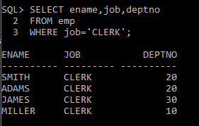SELECT ename,job,deptno

2 FROM emp

3 WHERE job='CLERK';

1. 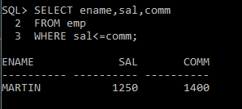SELECT ename,sal,comm

2 FROM emp

3 WHERE sal<=comm;

1. SELECT ename,sal

2 FROM emp

3 WHERE sal BETWEEN 1000 AND 1500;

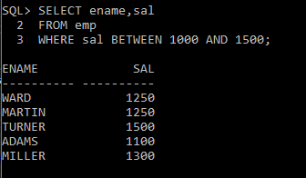

1. SELECT empno,ename,sal,mgr
   1. FROM emp

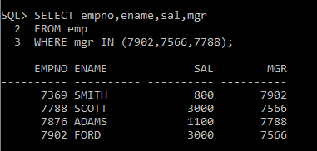3 WHERE mgr IN (7902,7566,7788);

1. SELECT ename

2 FROM emp

3 WHERE ename LIKE'_A%';

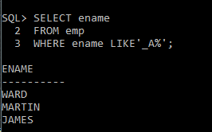

1. SELECT ename,mgr

2 FROM emp

3 WHERE mgr IS NULL;

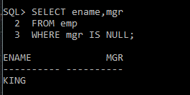

1. SELECT empno,ename,job,sal

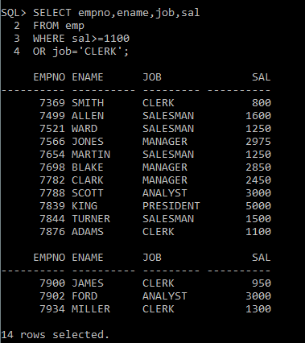 2 FROM emp

3 WHERE sal>=1100

4 OR job='CLERK';

1. SELECT ename,job

2 FROM emp

3 WHERE job NOT IN ('CLERK','MANAGER','ANALYST');

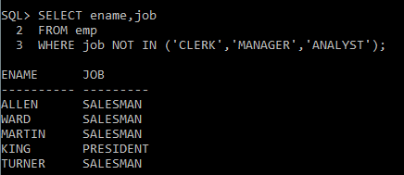

1. 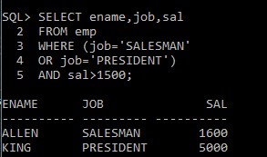SELECT ename,job,sal

2 FROM emp

3 WHERE (job='SALESMAN'

4 OR job='PRESIDENT')

5 AND sal>1500;

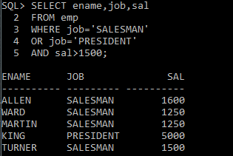

1. SELECT ename,job,sal

2 FROM emp

3 WHERE job='SALESMAN'

4 OR job='PRESIDENT'

5 AND sal>1500;

1. 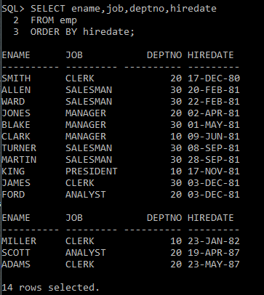SELECT ename,job,deptno,hiredate

2 FROM emp

3 ORDER BY hiredate;

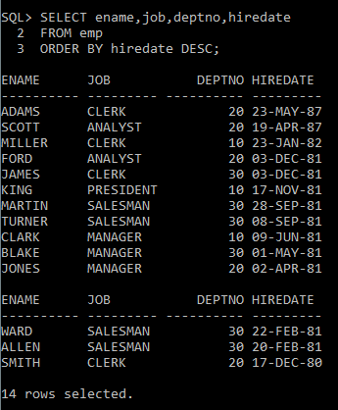

1. SELECT ename,job,deptno,hiredate

2 FROM emp

3 ORDER BY hiredate DESC;

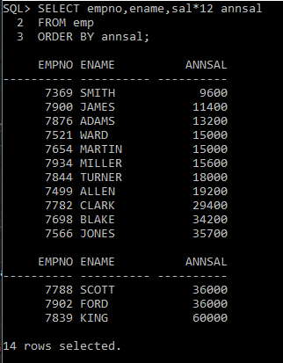

1. SELECT empno,ename,sal*12 annsal

2 FROM emp

3 ORDER BY annsal;

1. 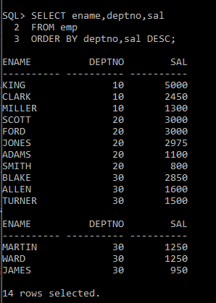 SELECT ename,deptno,sal

2 FROM emp

3 ORDER BY deptno,sal DESC;

**SLIDE – 06**

1. 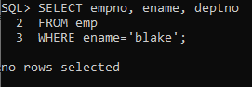SELECT empno, ename, deptno

2 FROM emp

3 WHERE ename='blake';

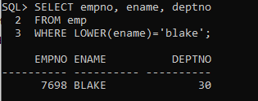

1. SELECT empno, ename, deptno

2 FROM emp

3 WHERE LOWER(ename)='blake';

1. SELECT ename, CONCAT (ename, job), LENGTH(ename),

2 INSTR(ename, 'A')

3 FROM emp

4 WHERE SUBSTR(job,1,5) = 'SALES';

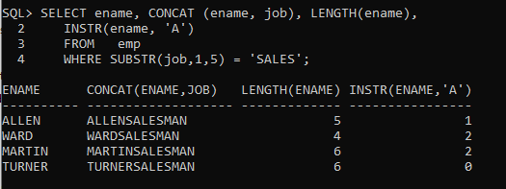

1. SELECT ROUND(45.923,2), ROUND(45.923,0),

2 ROUND(45.923,-1)

3 FROM DUAL;

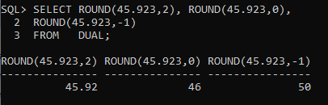

1. SELECT ename, sal, comm, MOD(sal, comm)

2 FROM emp

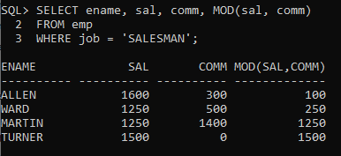3 WHERE job = 'SALESMAN';

1. SELECT ename, (SYSDATE-hiredate)/7 WEEKS

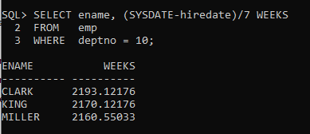 2 FROM emp

3 WHERE deptno = 10;

1. SELECT ename,

2 TO_CHAR(hiredate, 'fmDD Month YYYY') HIREDATE

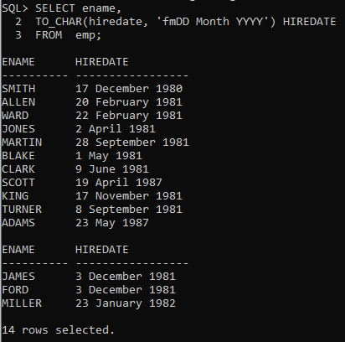 3 FROM emp;

1. SELECT TO_CHAR(sal,'$99,999') SALARY

2 FROM emp

3 WHERE ename = 'SCOTT';

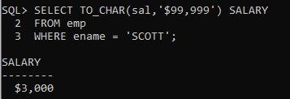

1. SELECT ename, sal, comm, (sal*12)+NVL(comm,0)

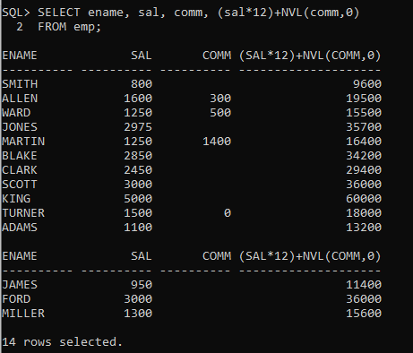 2 FROM emp;

1. 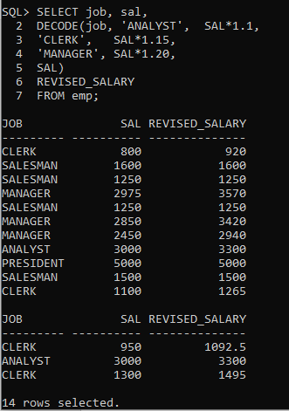SELECT job, sal,

2 DECODE(job, 'ANALYST', SAL*1.1,

3 'CLERK', SAL*1.15,

4 'MANAGER', SAL*1.20,

5 SAL)

6 REVISED_SALARY

7 FROM emp;

1. SELECT ename,

2 NVL(TO_CHAR(mgr),'No Manager')

3 FROM emp

4 WHERE mgr IS NULL;

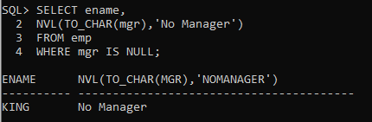

**SLIDE – 08**

1. 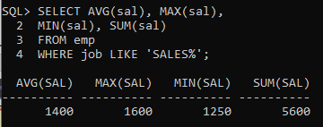SELECT AVG(sal), MAX(sal),

2 MIN(sal), SUM(sal)

3 FROM emp

4 WHERE job LIKE 'SALES%';

1. SELECT MIN(hiredate), MAX(hiredate)

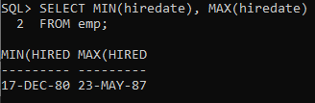 2 FROM emp;

1. SELECT COUNT(*)

2 FROM emp

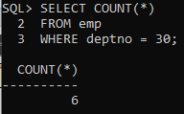 3 WHERE deptno = 30;

1. 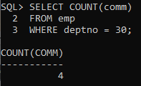SELECT COUNT(comm)

2 FROM emp

3 WHERE deptno = 30;

1. 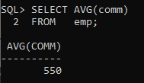 SELECT AVG(comm)

2 FROM emp;

1. 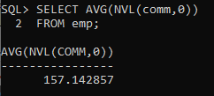SELECT AVG(NVL(comm,0))

2 FROM emp;

1. 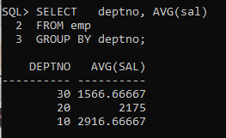 SELECT deptno, AVG(sal)

2 FROM emp

3 GROUP BY deptno;

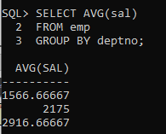

1. SELECT AVG(sal)

2 FROM emp

3 GROUP BY deptno;

1. SELECT deptno, job, sum(sal)

2 FROM emp

3 GROUP BY deptno, job;

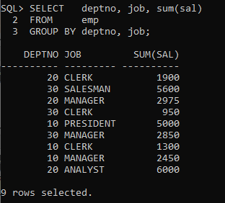

1. SELECT deptno, COUNT(ename)

2 FROM emp;

SELECT deptno, COUNT(ename)

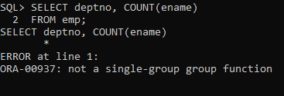

1. SELECT deptno, AVG(sal)

2 FROM emp

3 WHERE AVG(sal) > 2000

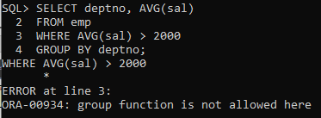 4 GROUP BY deptno;

1. 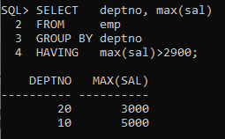SELECT deptno, max(sal)

2 FROM emp

3 GROUP BY deptno

4 HAVING max(sal)>2900;

1. 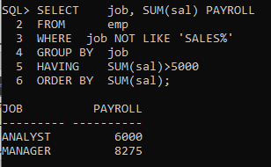SELECT job, SUM(sal) PAYROLL

2 FROM emp

3 WHERE job NOT LIKE 'SALES%'

4 GROUP BY job

5 HAVING SUM(sal)>5000

6 ORDER BY SUM(sal);

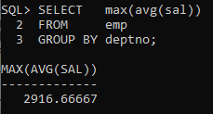

1. SELECT max(avg(sal))

2 FROM emp

3 GROUP BY deptno;